## Task 01: Create Ad Hoc SQL FIRST_VALUE, LAST_VALUE

Task goal: to identify tariffs that bring the highest and lowest profit by quarter from 2004 to 2008.

SELECT "YEAR" , "Quarter", tariff_type, tariff_name , tariff_code , count_tr , profit

FROM (SELECT "YEAR" , "Quarter" , tariff_type , tariff_name

, tariff_code , count_tr , profit ,

LAST_VALUE (

profit

)

OVER ( PARTITION BY "YEAR", "Quarter"

ORDER BY profit

ROWS BETWEEN UNBOUNDED PRECEDING AND UNBOUNDED FOLLOWING )

AS lv

, FIRST_VALUE (

profit

)

OVER ( PARTITION BY "YEAR", "Quarter"

ORDER BY profit

ROWS BETWEEN UNBOUNDED PRECEDING AND UNBOUNDED FOLLOWING )

AS fv

FROM ( SELECT TO_CHAR ( TRUNC ( event_dt

, 'YYYY' )

, 'YYYY' )

"YEAR"

, TO_CHAR ( TRUNC ( event_dt

, 'Q' )

, 'Q' )

"Quarter"

, tariff_type

, tariff_name

, tariff_code

, COUNT ( payment_sum / currency_to_dollar ) count_tr

, ROUND ( SUM ( ( payment_sum / currency_to_dollar ) * tariff_payment_sum / 100 )

, 2 )

profit

FROM u_dw_ext_references.tmp_transactions_info

WHERE tariff_type IN ('Local Transfer', 'International Transfer')

AND event_dt >= TRUNC ( TO_DATE ( '01-JAN-2004'

, 'dd-mon-yyyy' )

, 'month' )

AND event_dt <= (TRUNC ( TO_DATE ( ADD_MONTHS ( TO_DATE ( '01-JAN-2008'

, 'dd-mon-yyyy' )

, 1 ) )

, 'month' )

- 1)

GROUP BY tariff_type

, (tariff_code, tariff_name)

, TRUNC ( event_dt

, 'YYYY' )

, TRUNC ( event_dt

, 'Q' )))

WHERE profit = lv OR profit = fv

ORDER BY 1 , 2 , 3 , 7;

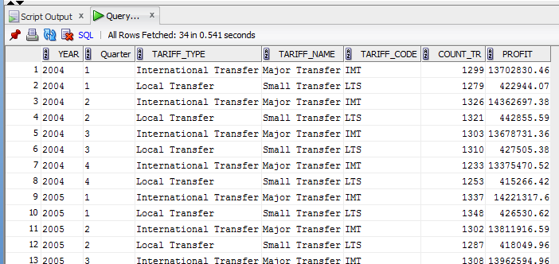

## Task 02: Create Ad Hoc SQL RANK, DENSE_RANK, ROWNUM

Task goal: to identify the top 5 countries in which the number of operations "deposit" was the highest by quarter in 2007 and 2008.

SELECT *

FROM (SELECT "YEAR"

, "Quarter"

, cust_rec_cntr

, count_tr

, DENSE_RANK ( ) OVER (PARTITION BY "YEAR", "Quarter" ORDER BY count_tr) RANK

FROM ( SELECT TO_CHAR ( TRUNC ( event_dt

, 'YYYY' )

, 'YYYY' )

"YEAR"

, TO_CHAR ( TRUNC ( event_dt

, 'Q' )

, 'Q' )

"Quarter"

, cust_rec_cntr

, COUNT ( transaction_id ) count_tr

FROM u_dw_ext_references.tmp_transactions_info

WHERE operation_name = 'DEPOSIT'

AND TO_CHAR ( TRUNC ( event_dt

, 'YYYY' )

, 'YYYY' ) IN ('2007', '2008')

GROUP BY cust_rec_cntr

, TRUNC ( event_dt

, 'YYYY' )

, TRUNC ( event_dt

, 'Q' )))

WHERE RANK < 4

ORDER BY 1

, 2

, RANK;

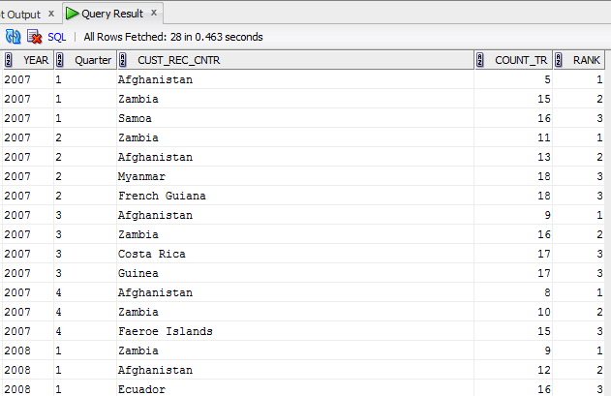

Task goal: to identify the country with the maximum amount of payments for the operation a "deposit" on quarters of 2007 and 2008

SELECT "YEAR"

, "Quarter"

, cust_rec_cntr

, TO_CHAR ( payment_sum ) || '$' payment_sum

FROM (SELECT "YEAR"

, "Quarter"

, cust_rec_cntr

, payment_sum

, ROW_NUMBER ( ) OVER (PARTITION BY "YEAR", "Quarter" ORDER BY payment_sum) RANK

FROM ( SELECT TO_CHAR ( TRUNC ( event_dt

, 'YYYY' )

, 'YYYY' )

"YEAR"

, TO_CHAR ( TRUNC ( event_dt

, 'Q' )

, 'Q' )

"Quarter"

, cust_rec_cntr

, SUM ( payment_sum ) payment_sum

FROM u_dw_ext_references.tmp_transactions_info

WHERE operation_name = 'DEPOSIT'

AND TO_CHAR ( TRUNC ( event_dt

, 'YYYY' )

, 'YYYY' ) IN ('2007', '2008')

GROUP BY cust_rec_cntr

, TRUNC ( event_dt

, 'YYYY' )

, TRUNC ( event_dt

, 'Q' )))

WHERE RANK = 1

ORDER BY 1

, 2

, RANK;

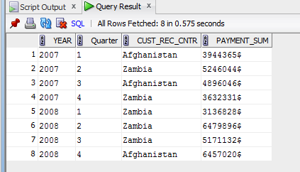

Task goal: to determine the top 10 countries with the largest number of operations "deposit" in 2001 and 2002 by quarter.

SELECT *

FROM (SELECT "YEAR"

, "Quarter"

, cust_rec_cntr

, count_tr

, RANK ( ) OVER (ORDER BY count_tr) RANK

FROM ( SELECT TO_CHAR ( TRUNC ( event_dt

, 'YYYY' )

, 'YYYY' )

"YEAR"

, TO_CHAR ( TRUNC ( event_dt

, 'Q' )

, 'Q' )

"Quarter"

, cust_rec_cntr

, COUNT ( transaction_id ) count_tr

FROM u_dw_ext_references.tmp_transactions_info

WHERE operation_name = 'DEPOSIT'

AND TO_CHAR ( TRUNC ( event_dt

, 'YYYY' )

, 'YYYY' ) IN ('2002', '2001')

GROUP BY cust_rec_cntr

, TRUNC ( event_dt

, 'YYYY' )

, TRUNC ( event_dt

, 'Q' )))

WHERE RANK < 10

ORDER BY RANK;

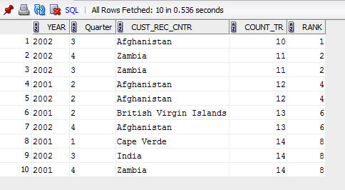

## Task 03: Create Ad Hoc SQL AGGREAGATE FUNCS

SELECT DISTINCT

"YEAR"

, "Quarter"

, cust_rec_cntr

, payment_sum

, CASE

WHEN payment_sum = min_payment_sum THEN 'minimum payments' || ' ' || "YEAR" || '-' || "Quarter" || ' Q'

ELSE 'maximum payments' || ' ' || "YEAR" || '-' || "Quarter" || ' Q'

END

lv

FROM (SELECT "YEAR"

, "Quarter"

, cust_rec_cntr

, payment_sum

, MIN ( payment_sum ) OVER (PARTITION BY "YEAR", "Quarter") min_payment_sum

, MAX ( payment_sum ) OVER (PARTITION BY "YEAR", "Quarter") max_payment_sum

FROM (SELECT TO_CHAR ( TRUNC ( event_dt

, 'YYYY' )

, 'YYYY' )

"YEAR"

, TO_CHAR ( TRUNC ( event_dt

, 'Q' )

, 'Q' )

"Quarter"

, cust_rec_cntr

, ROUND ( AVG ( payment_sum ) OVER (PARTITION BY cust_rec_cntr) ) payment_sum

FROM u_dw_ext_references.tmp_transactions_info

WHERE operation_name = 'DEPOSIT'

AND TO_CHAR ( TRUNC ( event_dt

, 'YYYY' )

, 'YYYY' ) IN ('2012')

AND TO_CHAR ( TRUNC ( event_dt

, 'Q' )

, 'Q' ) IN ('1')))

WHERE payment_sum = min_payment_sum

OR payment_sum = max_payment_sum

ORDER BY 1

, 2

, payment_sum;

